+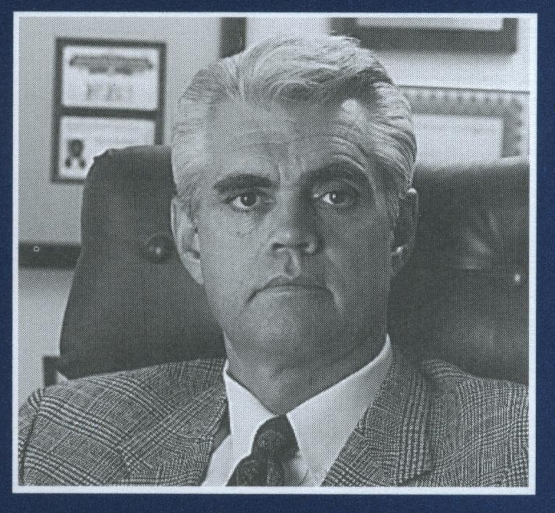  Charles P. Stephenson  Former FBI Agent  President  The Orion Group  Orion Security Inc.  Alcops LLC  Managing Partner  Midwest Security Guards LLC  www.kcdetective.com  www.kcguards.com  www.alcops.com  913- 385-5657 | THE ORION BULLET  A Professional Security Publication
July 30, 2026
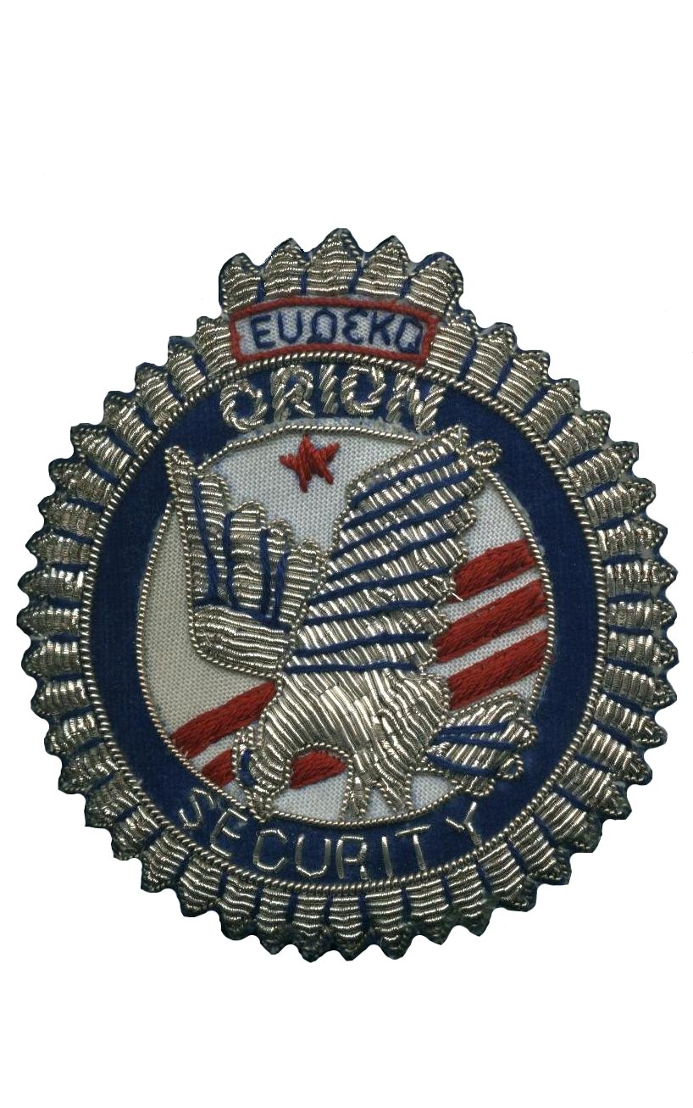  Orion Group Services:  Civil/Criminal Investigations  Risk management Evaluations  Litigation Support Services  Expert Witness Testimony,  Federal/State Certified:  Litigation support - Lethal Force – Police Certified  Public and Contract Security Officers:  *Inadequate Security  *Lack of Planning and Implementation  * Inappropriate and or Excessive use of Force  *Firearms Use and training  Executive Protection/Firearms  Training/State Certified  Carry Concealed Handgun  Video Surveillance Systems  Contract Security Guards  Mobile Patrol/Cash Courier  Neighborhood Watch Programs  Pre-Employment/Background Investigations  Employee Performance  Audits/Mystery Shopping    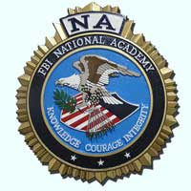       | USE OF FORCE/LETHAL/NON-LETHAL/ CARRYING OF FIREARMS  By  The Private Citizen  The right of self-defense and use of reasonable force is a well-recognized caveat within our legal system. Dependent on the totality of the circumstance, the Use Of Force by a private citizen including lethal force may be deemed reasonable and lawful.  However, the force used can only be equal to the force being deployed by an assailant and must cease once the threat  or use of force is no longer present.  For purpose of this discussion force can be defined as :  Lethal (force intended or likely to cause death or great bodily harm);  The use of lethal force may be deemed unreasonable and a criminal violation if less lethal force would have been sufficient to avert a threatened harm.  Less Lethal (Force neither intended nor likely to cause death).  Less Lethal force may be considered unreasonable and a criminal violation if the force used was in excess of what was needed to protect one’s self.  The legal guidelines for Use Of Force by a citizen versus a Law Enforcement Officer are alike in some ways but dramatically different in other ways.  Neither the private citizen nor Law Enforcement Officer ever lose the inherent right of self-defense.  However the Law Enforcement Officer’s unique status of having an obligation to arrest and detain individuals has resulted in case law that guides their Use Of Force.  Although Graham V. Conner does not directly apply to the private citizen it may be helpful to consider some of the issues examined in an officer involved Use Of Force incident as to whether it was reasonable or unreasonable.  * What was the immediate threat to the safety of others?  * Were the circumstances tense, uncertain, and /or involving a rapidly evolving pace of events?  * What was the severity of the crime?  * Was the subject attempting to evade arrest and seizure by flight?  In Chew V. Gates, the 9th Circuit Court of Appeals provided other standards to be considered in the Use Of Force by a  Law Enforcement Officer:  * What was the availability of less  injurious alternatives or methods of force  to use when capturing or subduing a suspect?  * What was the available knowledge known about the suspects’ health, mental condition, or relevant fragilities?  * Were appropriate warnings given before use of force.  Again the above case law only applies to Law Enforcement Officers and their use of force under the Fourth amendment under 4th amendment guidelines.  This is not the case for the private citizen who is carrying a firearm or other less lethal device.  For the private citizen whether or not Use Of Force was reasonable or legal will be determined by application of criminal/civil codes.  For the private citizen it is not sufficient to simply comply with local laws concerning the carrying of weapons.  A complete understanding of Use Of Force as it applies to the concept of Self-defense is essential to limit ones exposure to criminal prosecution and or civil litigation.  References :  Graham V. Conner,490 U.S. 386, 396,104 L.Ed.2d 443,109 S. Ct 1865(1989)  Chew V. Gates, 27 F. 3d 1432(9th cir.  1994).cert. denied, 513 U.S. 1148, 115 S.Ct. 1097, 130 L.Ed.2nd d1065 (1995).  As of July, 1st 2015 residents of the State of Kansas 21 years of age or older may carry a concealed firearm without a concealed carry permit or training in any venue. Open carry of a firearm in Kansas was approved on July 15, 2014.

